ELEC 2110

Electric Circuit Analysis

Gabriel Emerson

Jake Bryson

October 29, 2019

Section 002

Recitation and MATLAB: AC Mesh and Nodal Analysis

Introduction

Lab 10 is for the student to practice solving ac circuits and also learn to start using MATLAB to solve the circuit variables by inserting circuit equations.

Exercise 1

Use MATLAB to solve the following set of equations. Then convert them to polar form.

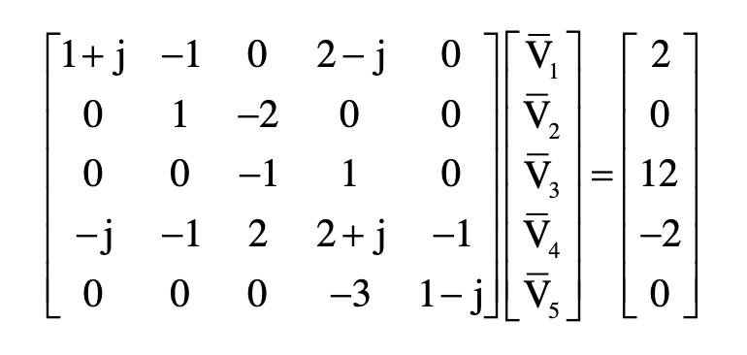

(1)

Equations for exercise 1

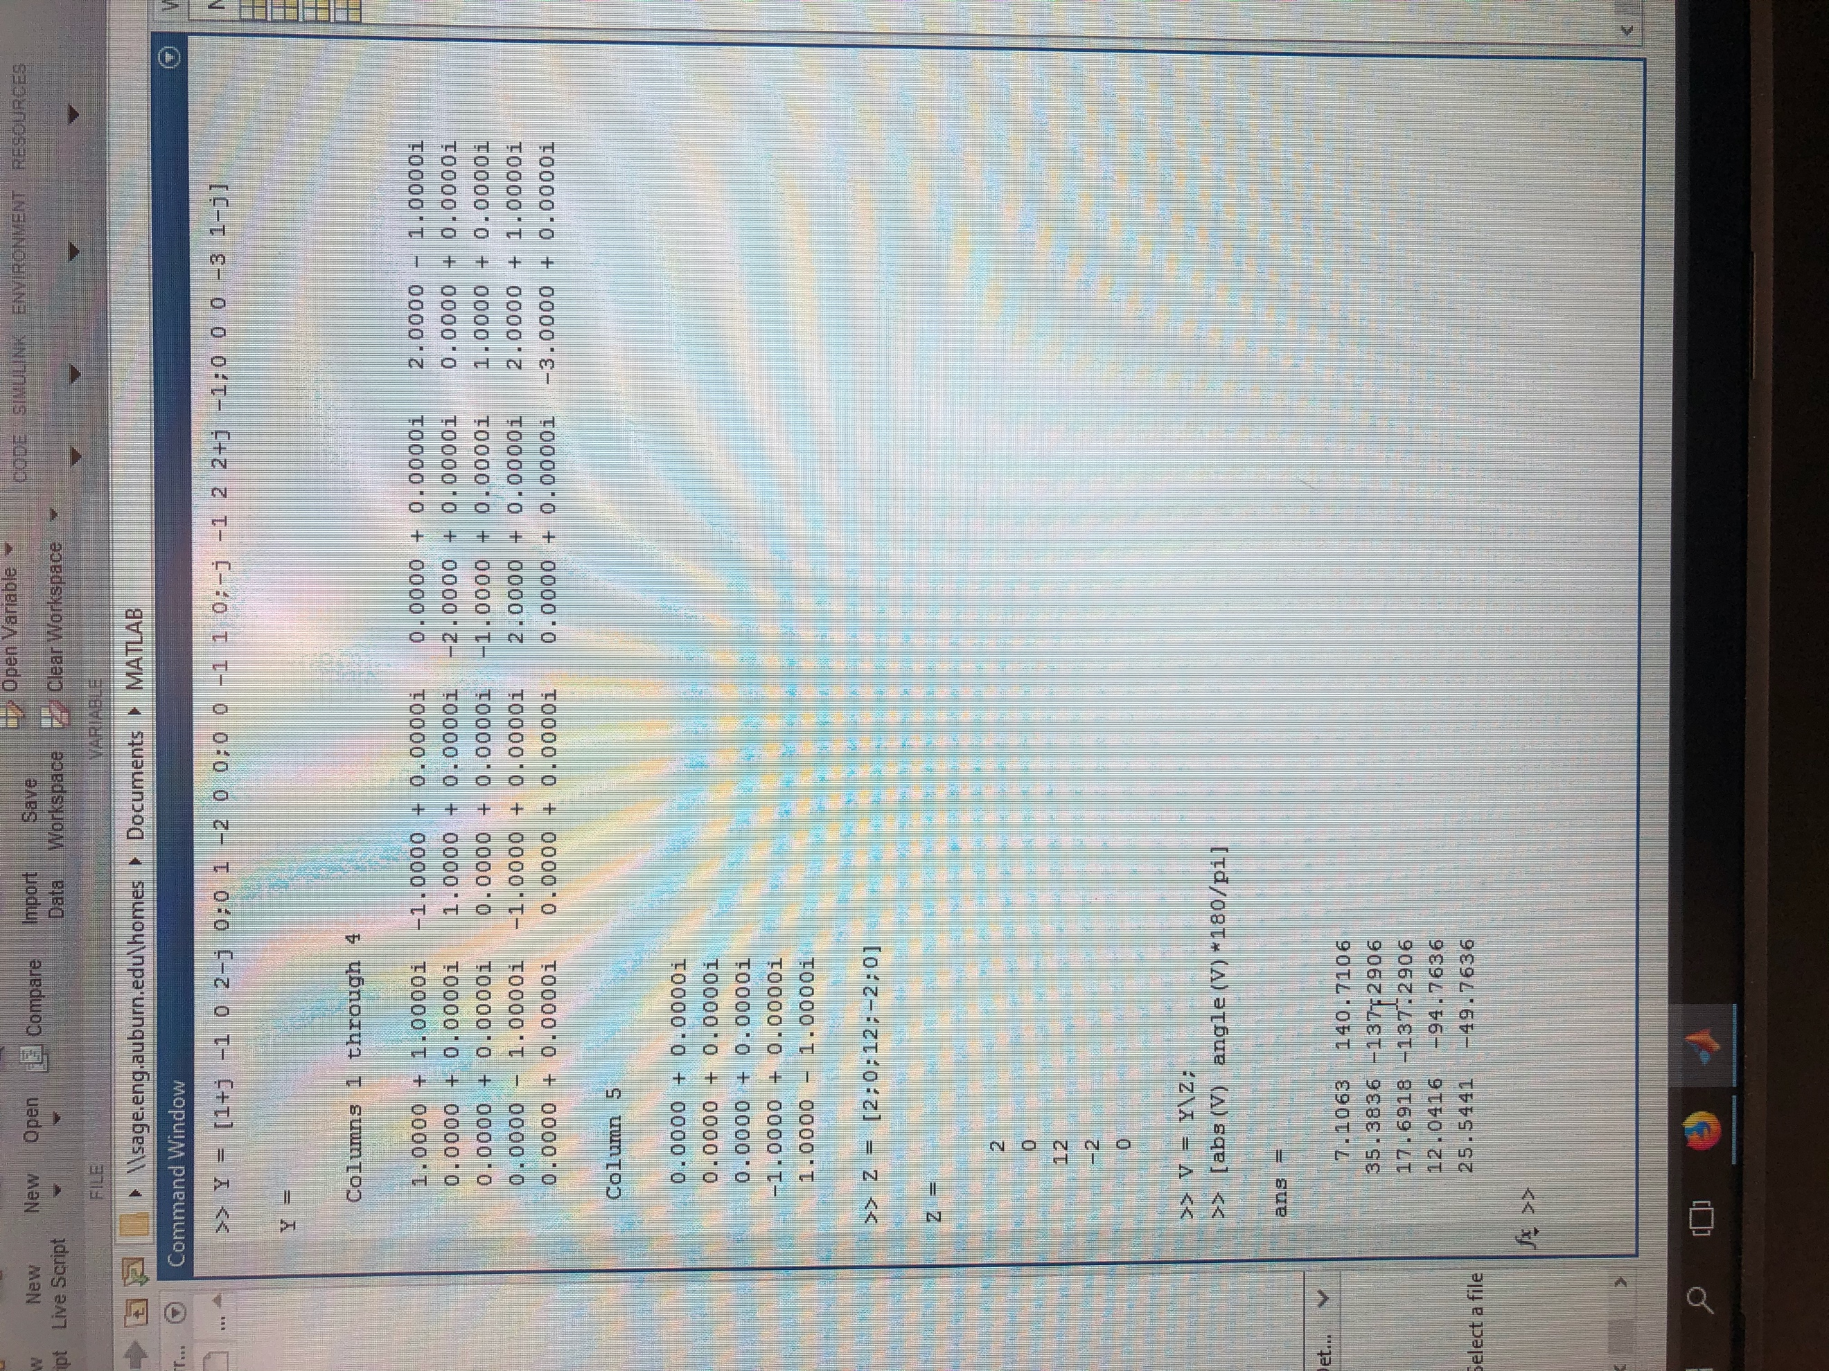

(2)

MATLAB code

Summary Table (In Polar Form)

|  |  |
| --- | --- |
| **Vector** | **Angle (degrees)** |
| 7.1063 | 140.7106 |
| 35.3836 | -137.2906 |
| 17.6918 | -137.2906 |
| 12.0416 | -94.7636 |
| 25.5441 | -49.7636 |

Exercise 2

Write nodal equations for the circuit and solve using MATLAB. Then repeat using mesh analysis.

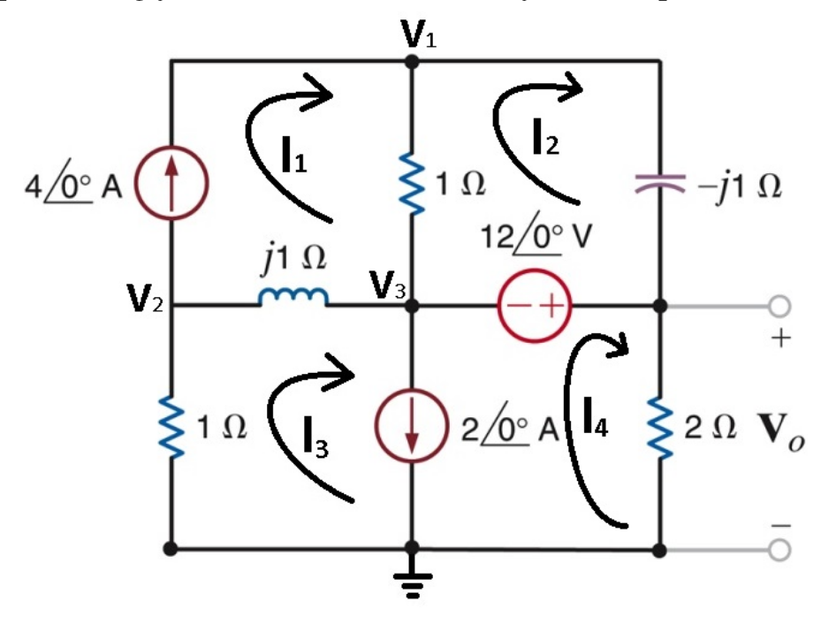

(3)

Circuit for exercise 2

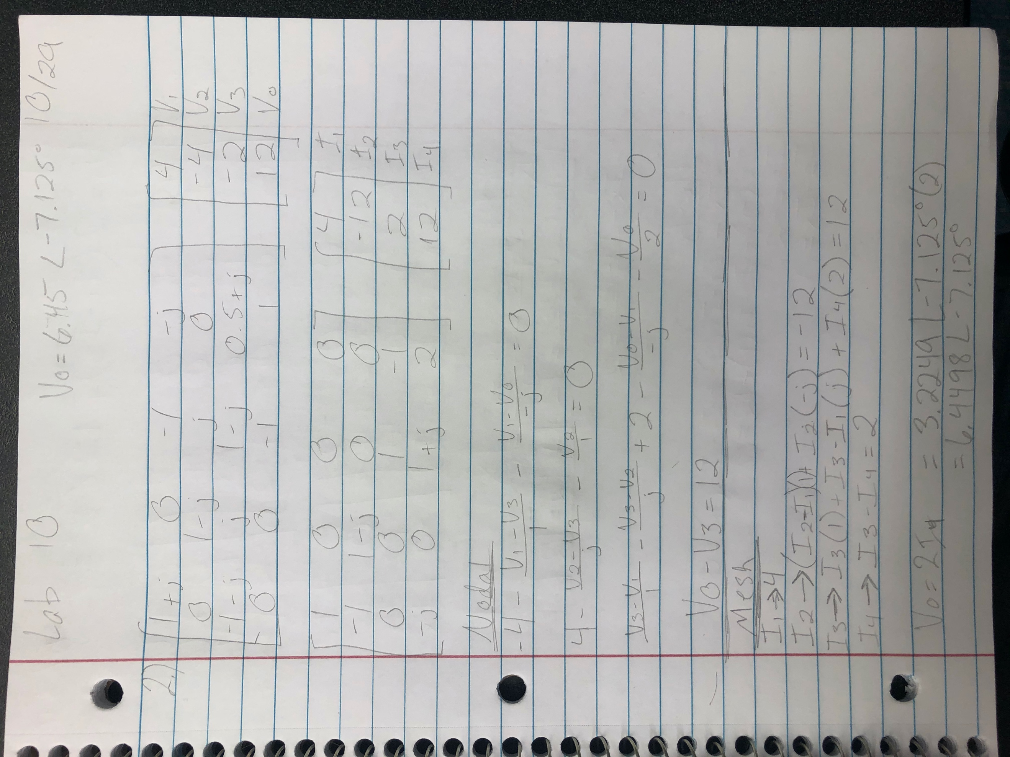

(4)

Equations for exercise 2

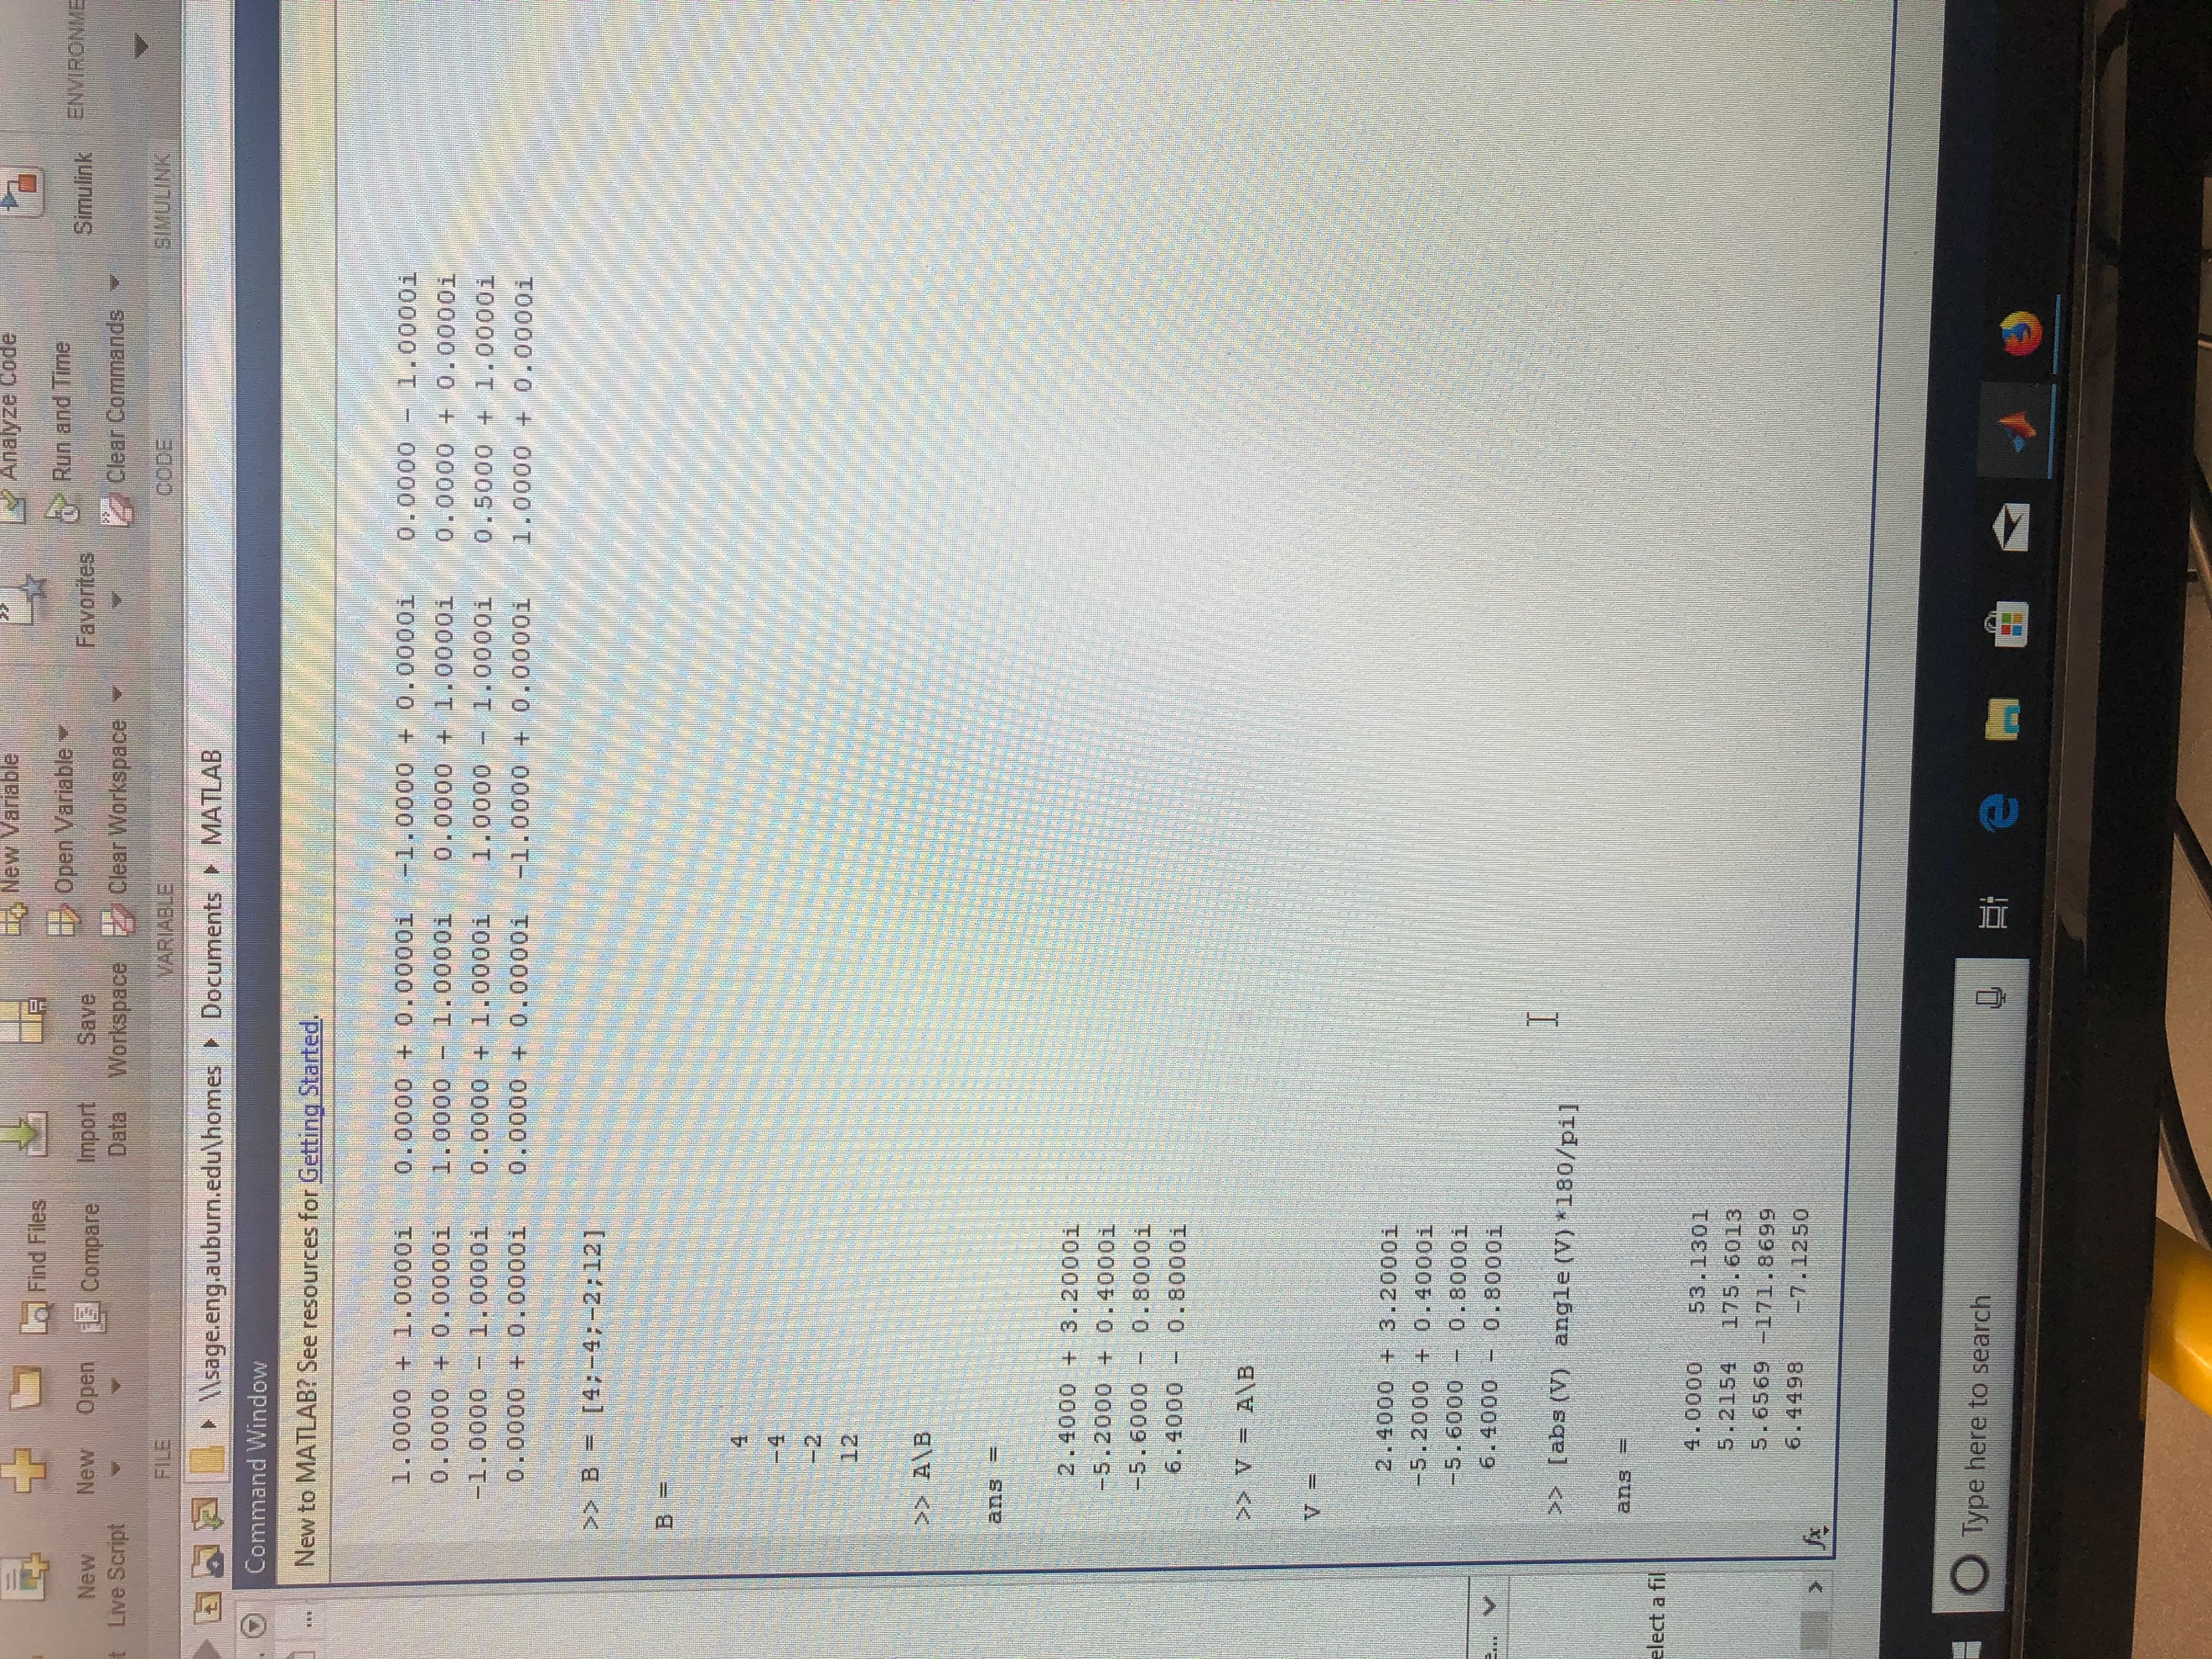

Nodal equations MATLAB (5)

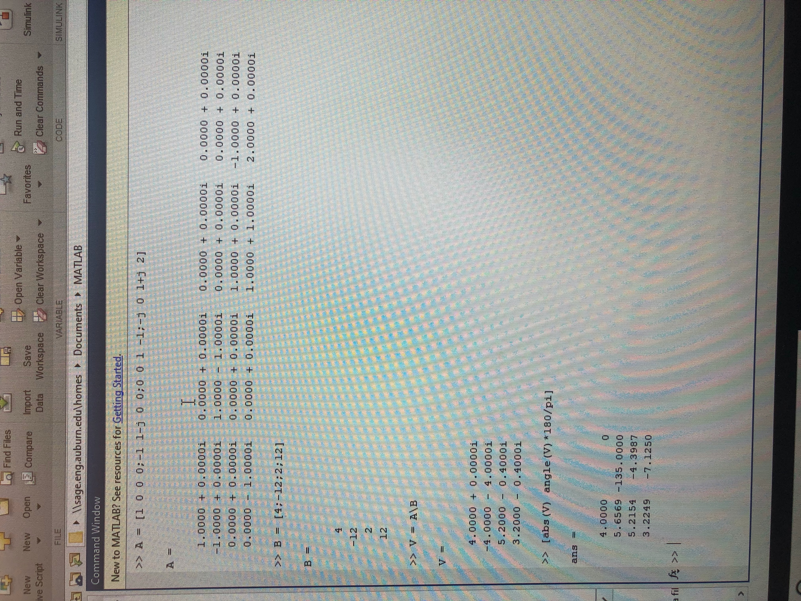

Mesh equations MATLAB (6)

Nodal Summary Table (In Polar Form)

|  |  |  |
| --- | --- | --- |
|  | **Vector** | **Angle (degrees)** |
| **V1** | 4.00 | 53.1301 |
| **V2** | 5.2154 | 175.6013 |
| **V3** | 5.6569 | -171.8699 |
| **Vo** | 6.4498 | -7.1250 |

**Vo = Vo =** 6.4498 <-7.1250 V

Mesh Summary Table (In Polar Form)

|  |  |  |
| --- | --- | --- |
|  | **Vector** | **Angle (degrees)** |
| **I1** | 4.00 | 0 |
| **I2** | 5.6569 | -135.00 |
| **I3** | 5.2154 | -4.3987 |
| **I4** | 3.2249 | -7.1250 |

**Vo = I4 * 2 =** 2 * 3.2249 <-7.1250 = 6.4498 <-7.1250 V

Exercise 3

Write nodal equations for the circuit and solve using MATLAB. Then repeat using mesh analysis.

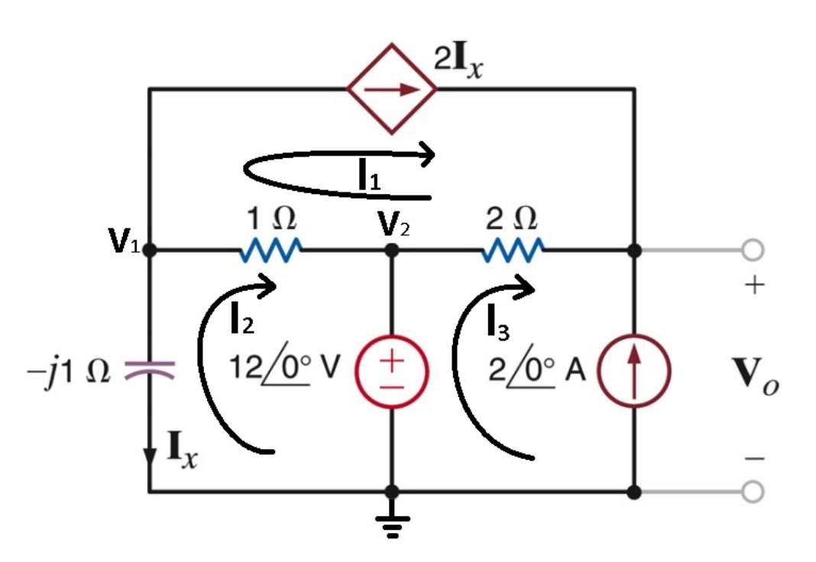

(7)

Circuit for exercise 3

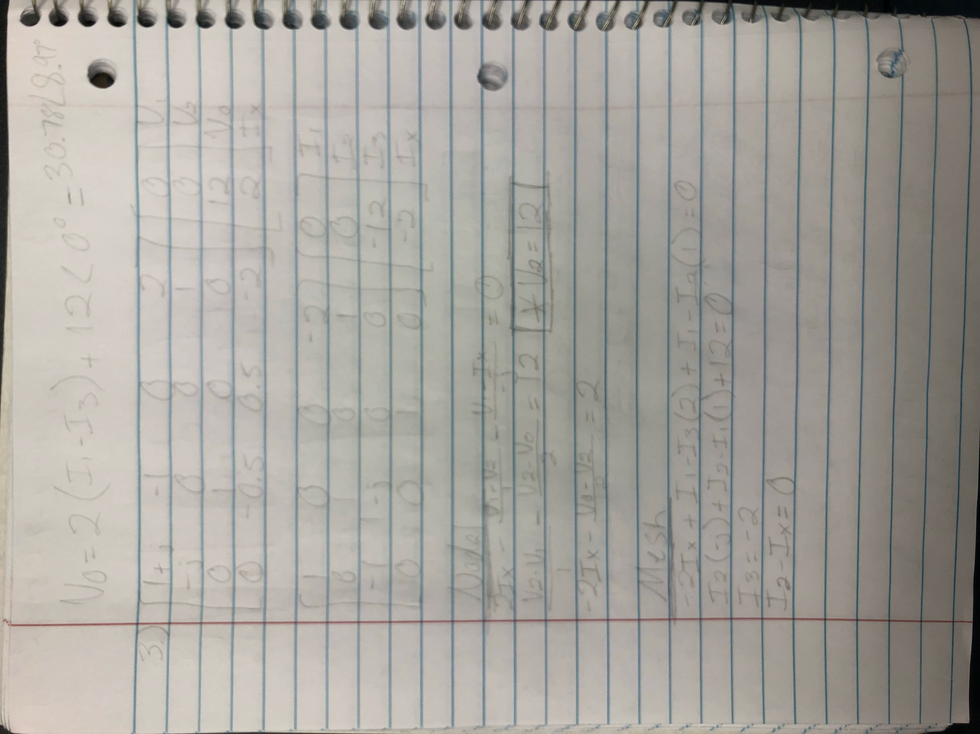

(8)

Equations for exercise 3

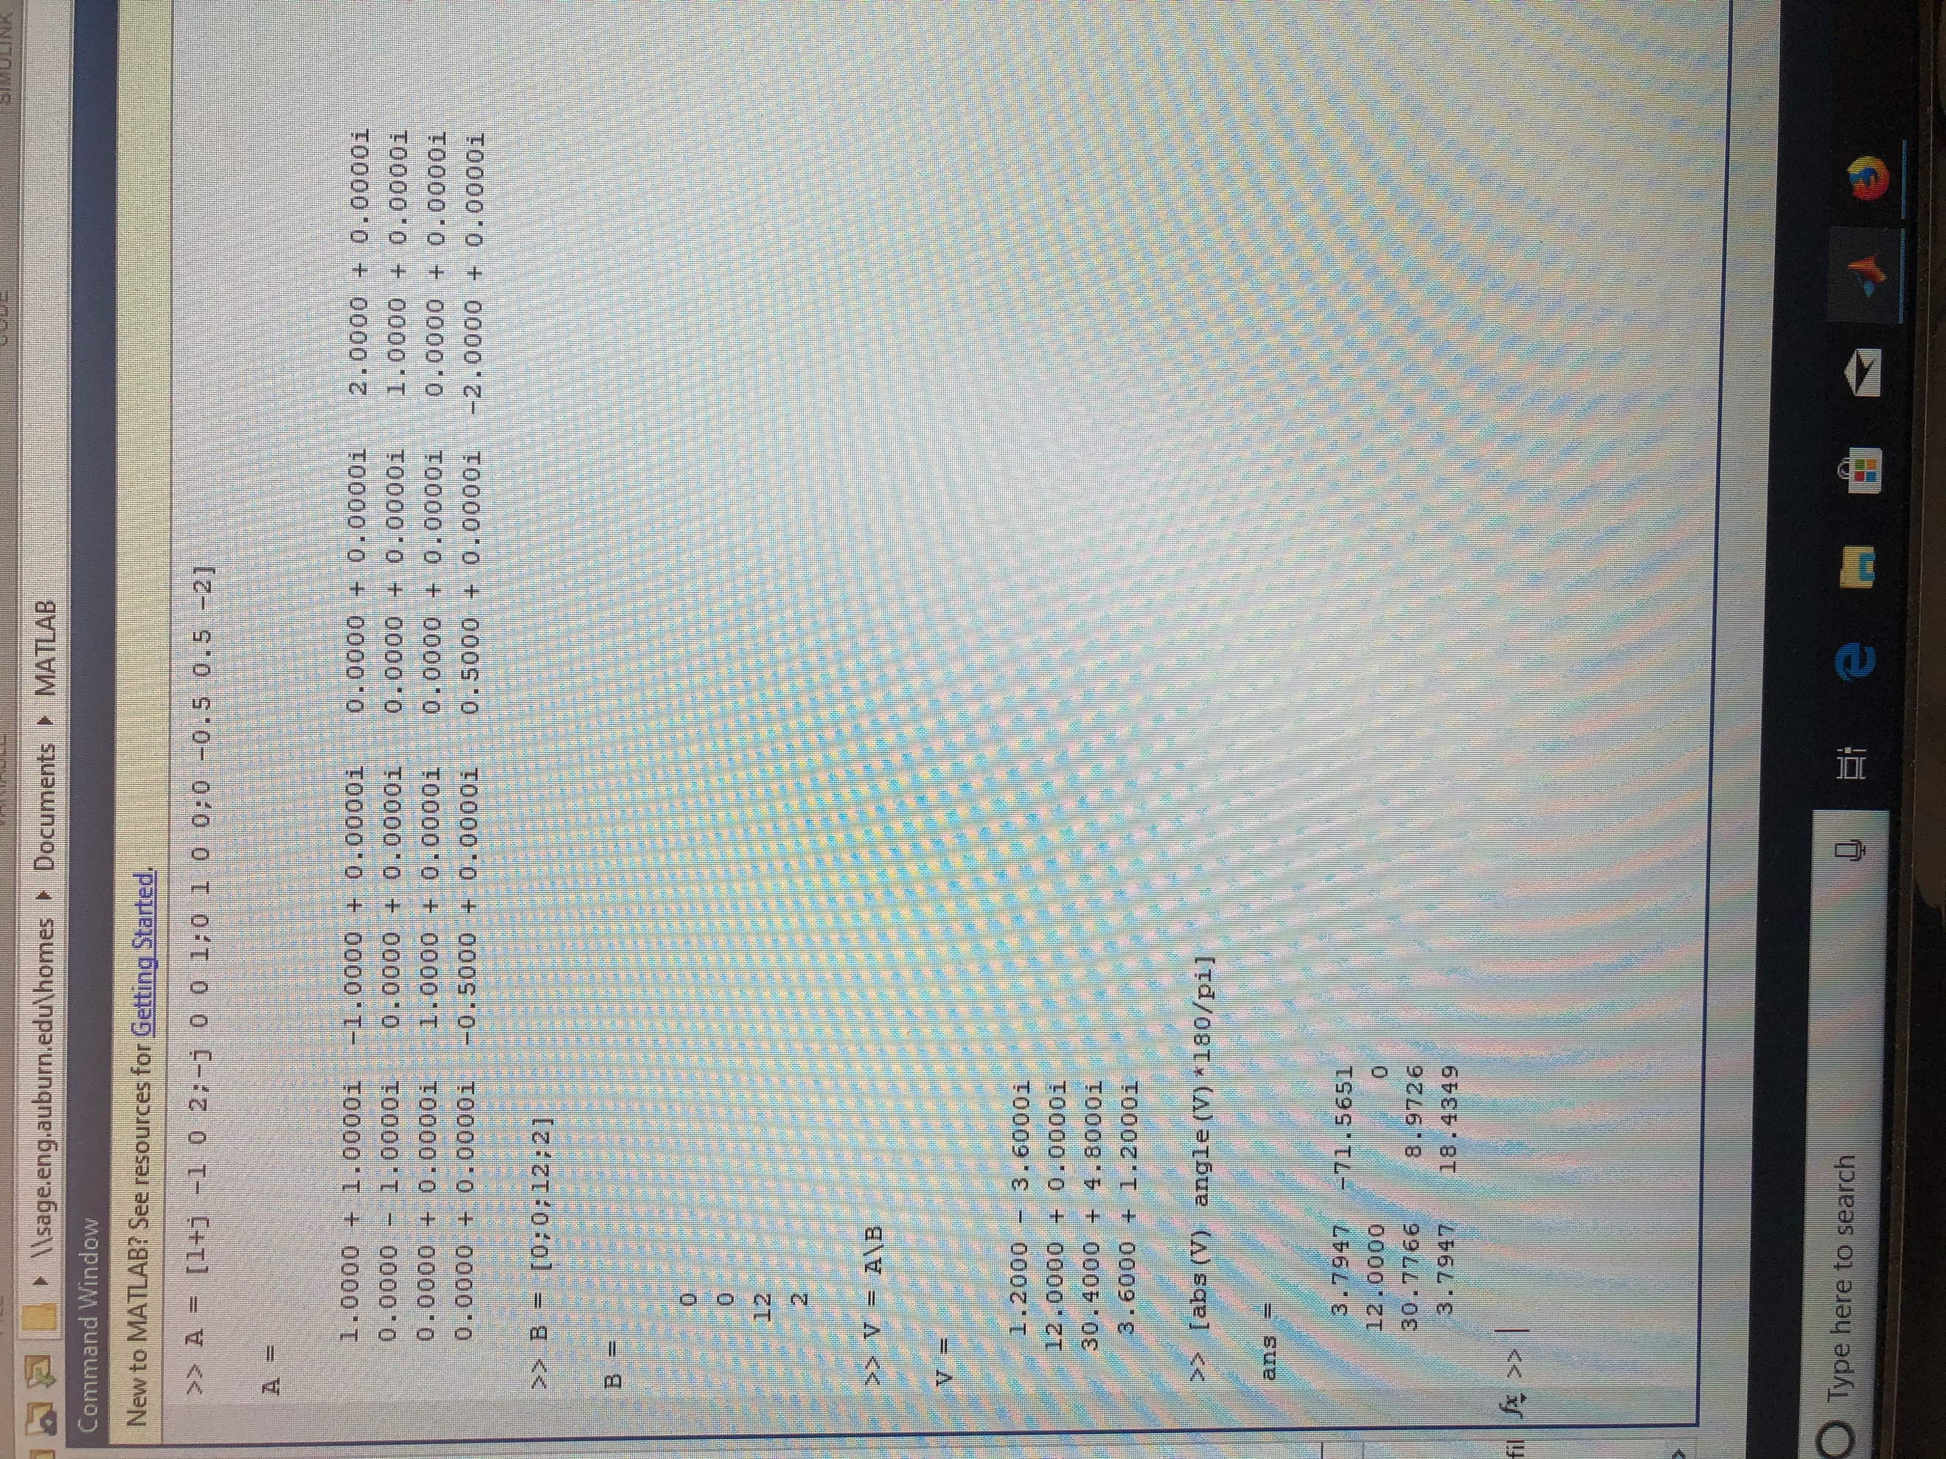

Nodal equations MATLAB (9)

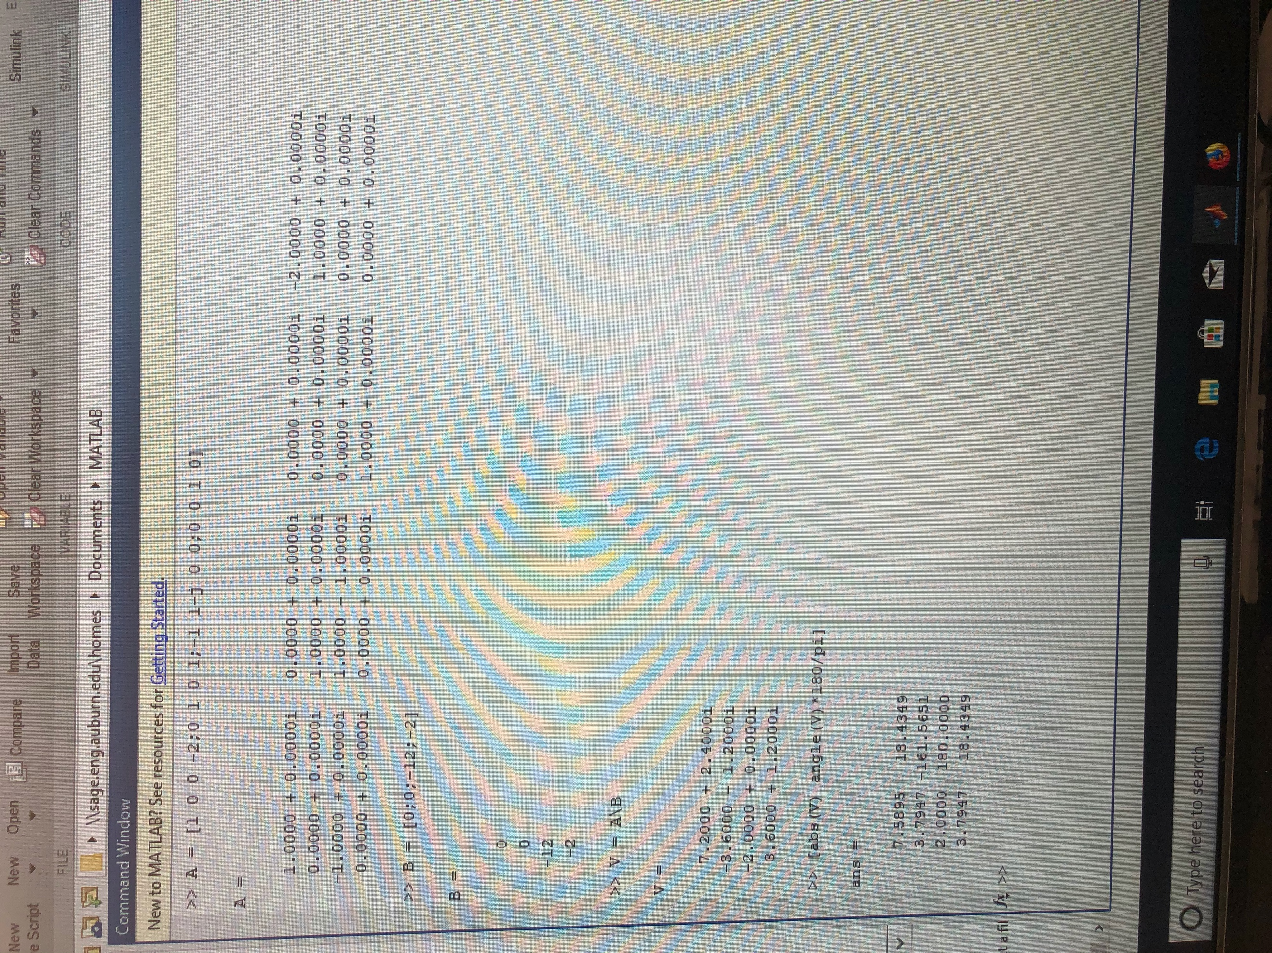

Mesh equations MATLAB (10)

Nodal Summary Table (In Polar Form)

|  |  |  |
| --- | --- | --- |
|  | **Vector** | **Angle (degrees)** |
| **V1** | 3.7947 | -71.5651 |
| **V2** | 12.00 | 0 |
| **Vo** | 30.7766 | 8.9726 |
| **Ix** | 3.7947 | 18.4349 |

**Vo = Vo =** 30.7766 <8.9726 V

Mesh Summary Table (In Polar Form)

|  |  |  |
| --- | --- | --- |
|  | **Vector** | **Angle (degrees)** |
| **I1** | 7.5895 | 18.4349 |
| **I2** | 3.7947 | -161.5651 |
| **I3** | 2.00 | 180 |
| **Ix** | 3.7947 | 18.4349 |

**Vo = 2(I1-I3) + 12 =** 2(7.5895 <18.4349 – 2.00 < 180) + 12 <0 = 30.7766 <8.9726 V

Exercise 4

Write nodal equations for the circuit and solve using MATLAB. Then repeat using mesh analysis.

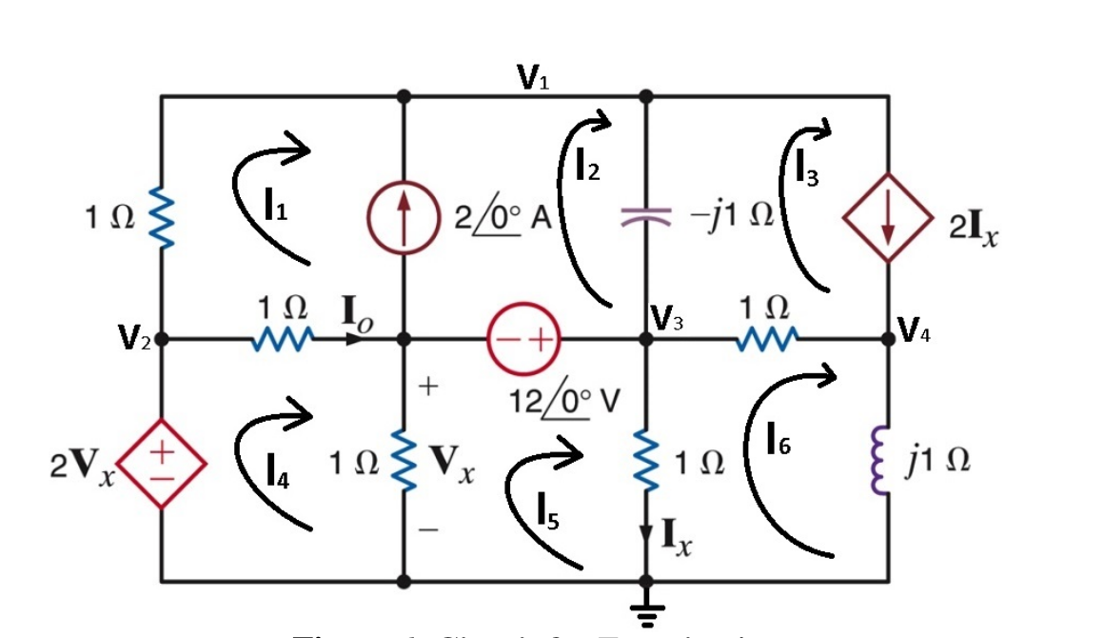

Circuit for exercise 4 (11)

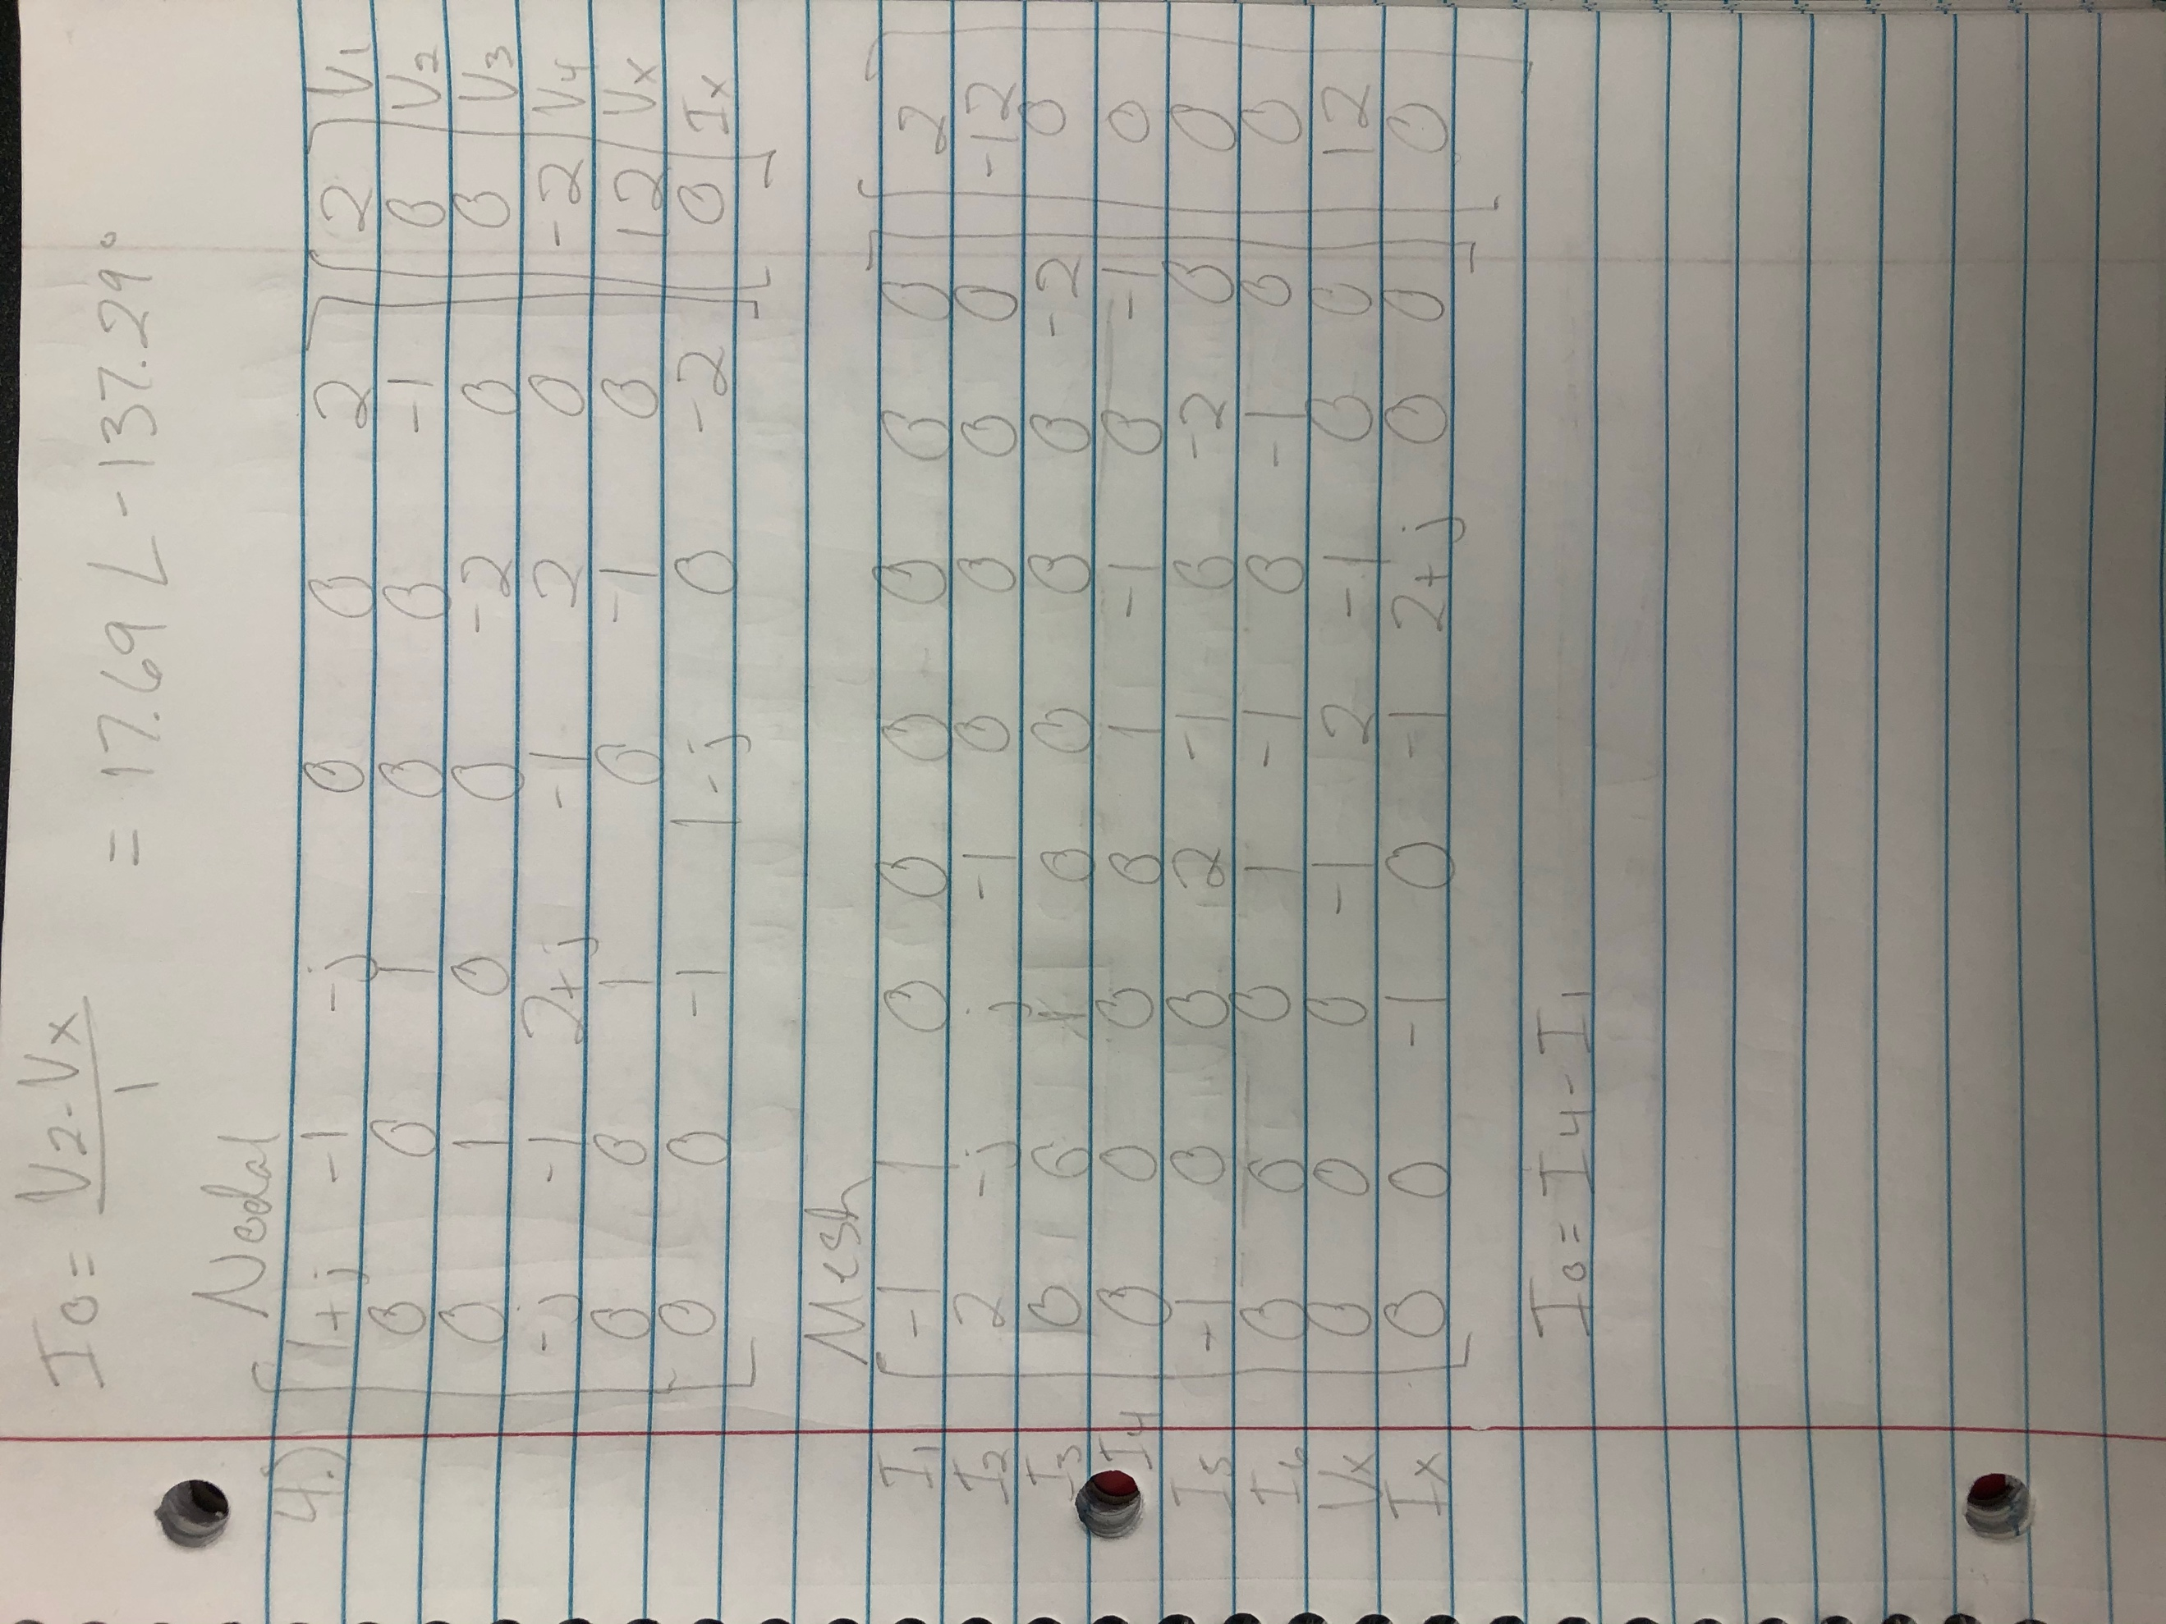

(12)

Equations for exercise 4

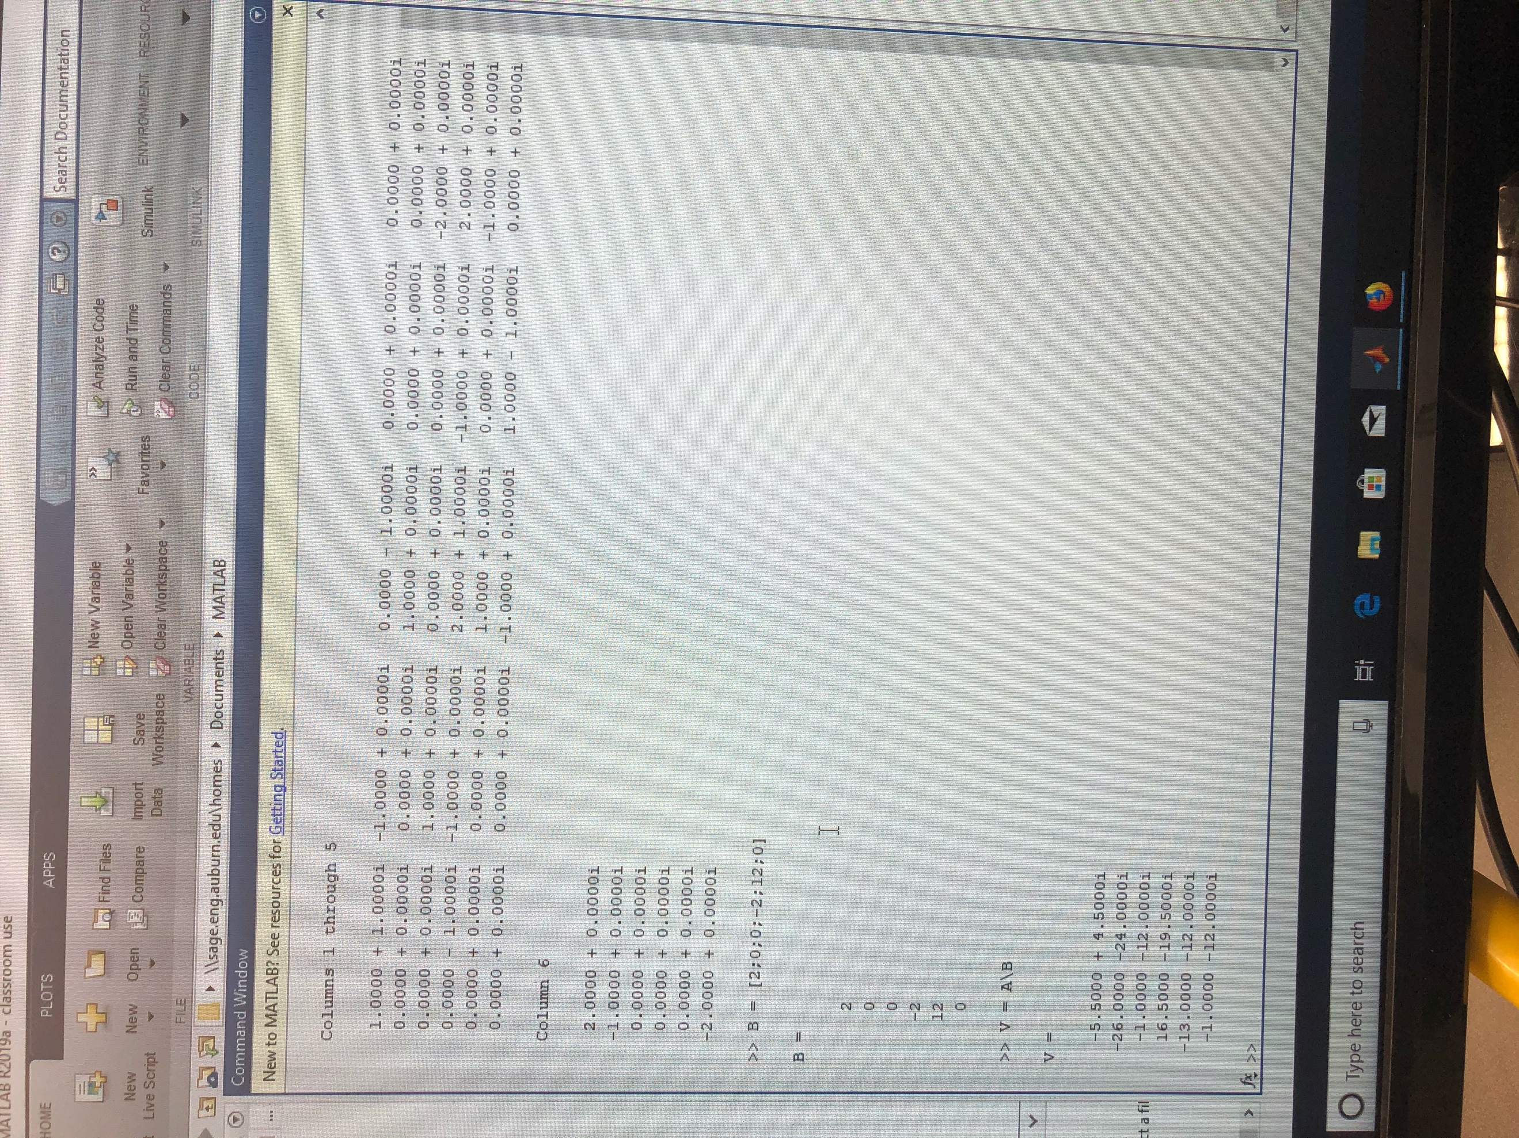

(13)

Nodal equations MATLAB **Not in Polar form**

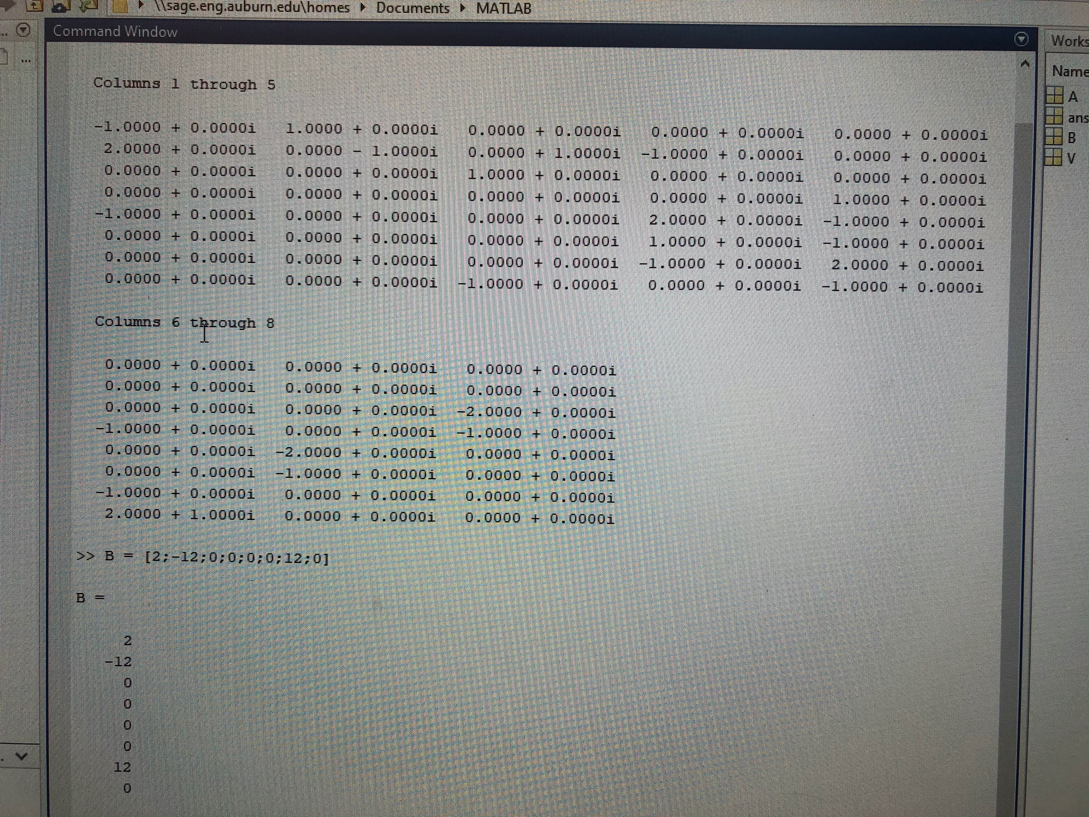

Mesh equations MATLAB part 1 (14)

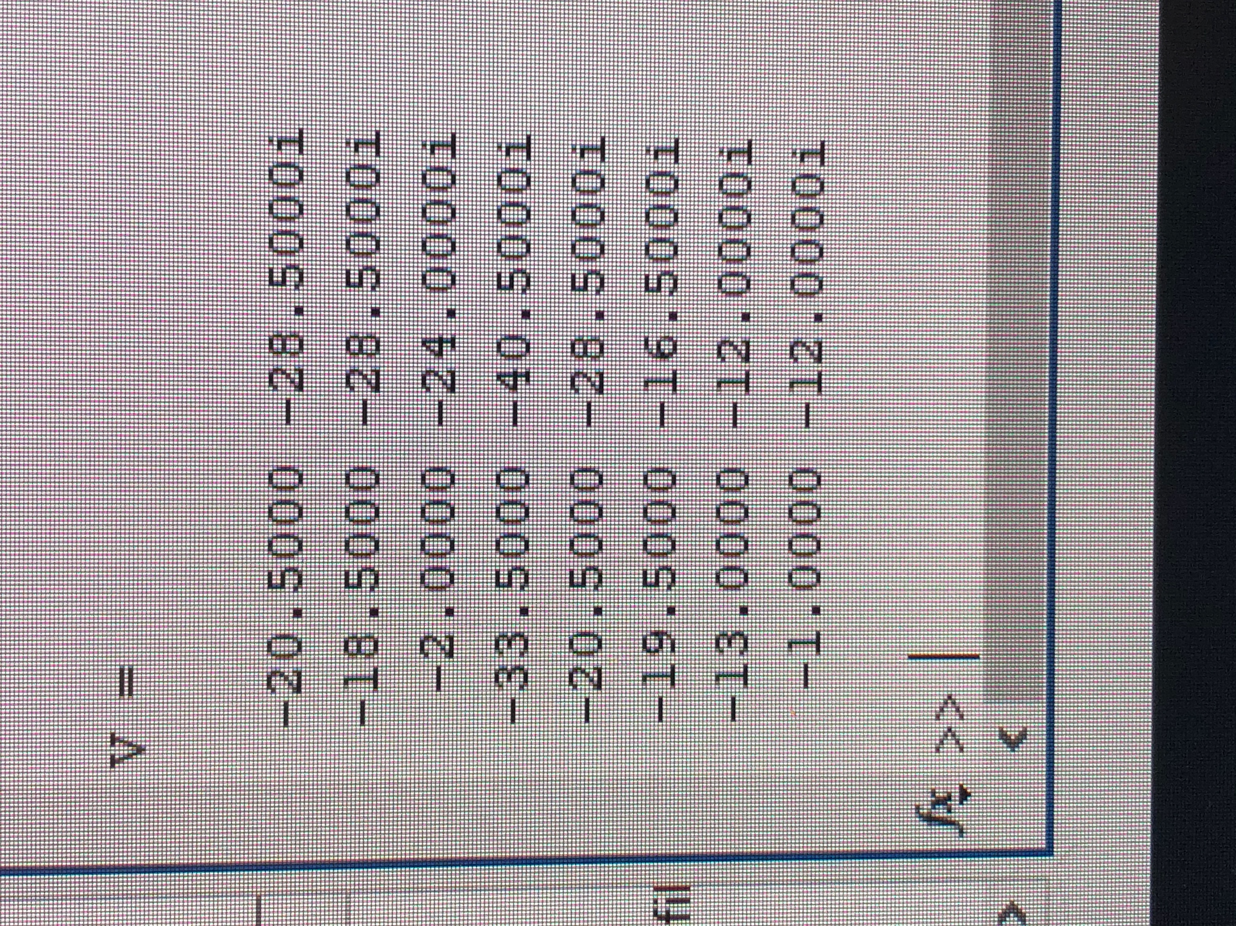

Mesh equations MATLAB part 2 (15) **Not in Polar form**

Nodal Summary Table (In Polar Form)

|  |  |  |
| --- | --- | --- |
|  | **Vector** | **Angle (degrees)** |
| **V1** | 7.10634 | 140.711 |
| **V2** | 35.3836 | -137.291 |
| **V3** | 12.0416 | -94.7636 |
| **V4** | 25.5441 | -130.236 |
| **Vx** | 17.6918 | -137.291 |
| **Ix** | 12.0416 | -94.7636 |

**Io = (V2 – Vx)/1 =** 35.3836 <-137.291 – 17.6918 <-137.291 = 17.69 <-137.291 A

Mesh Summary Table (In Polar Form)

|  |  |  |
| --- | --- | --- |
|  | **Vector** | **Angle (degrees)** |
| **I1** | 35.107 | -125.727 |
| **I2** | 33.9779 | -122.989 |
| **I3** | 24.0832 | -94.7636 |
| **I4** | 52.5595 | -129.596 |
| **I5** | 35.107 | -125.727 |
| **I6** | 25.5441 | -139.764 |
| **Vx** | 17.6918 | -137.291 |
| **Ix** | 12.0416 | -94.7636 |

**Io = I4 – I1 =** 52.5595 <-129.596 – 35.107 <-125.727 = 17.69 <-137.291 A

Exercise 5

Write nodal equations for the circuit and solve using MATLAB.

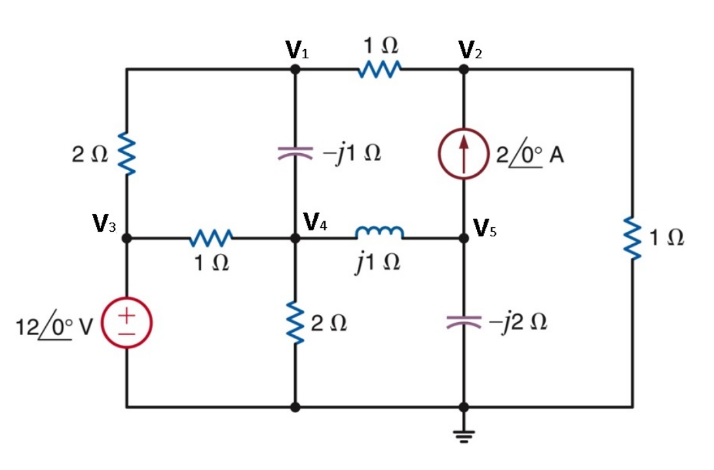

Circuit for exercise 5 (16)

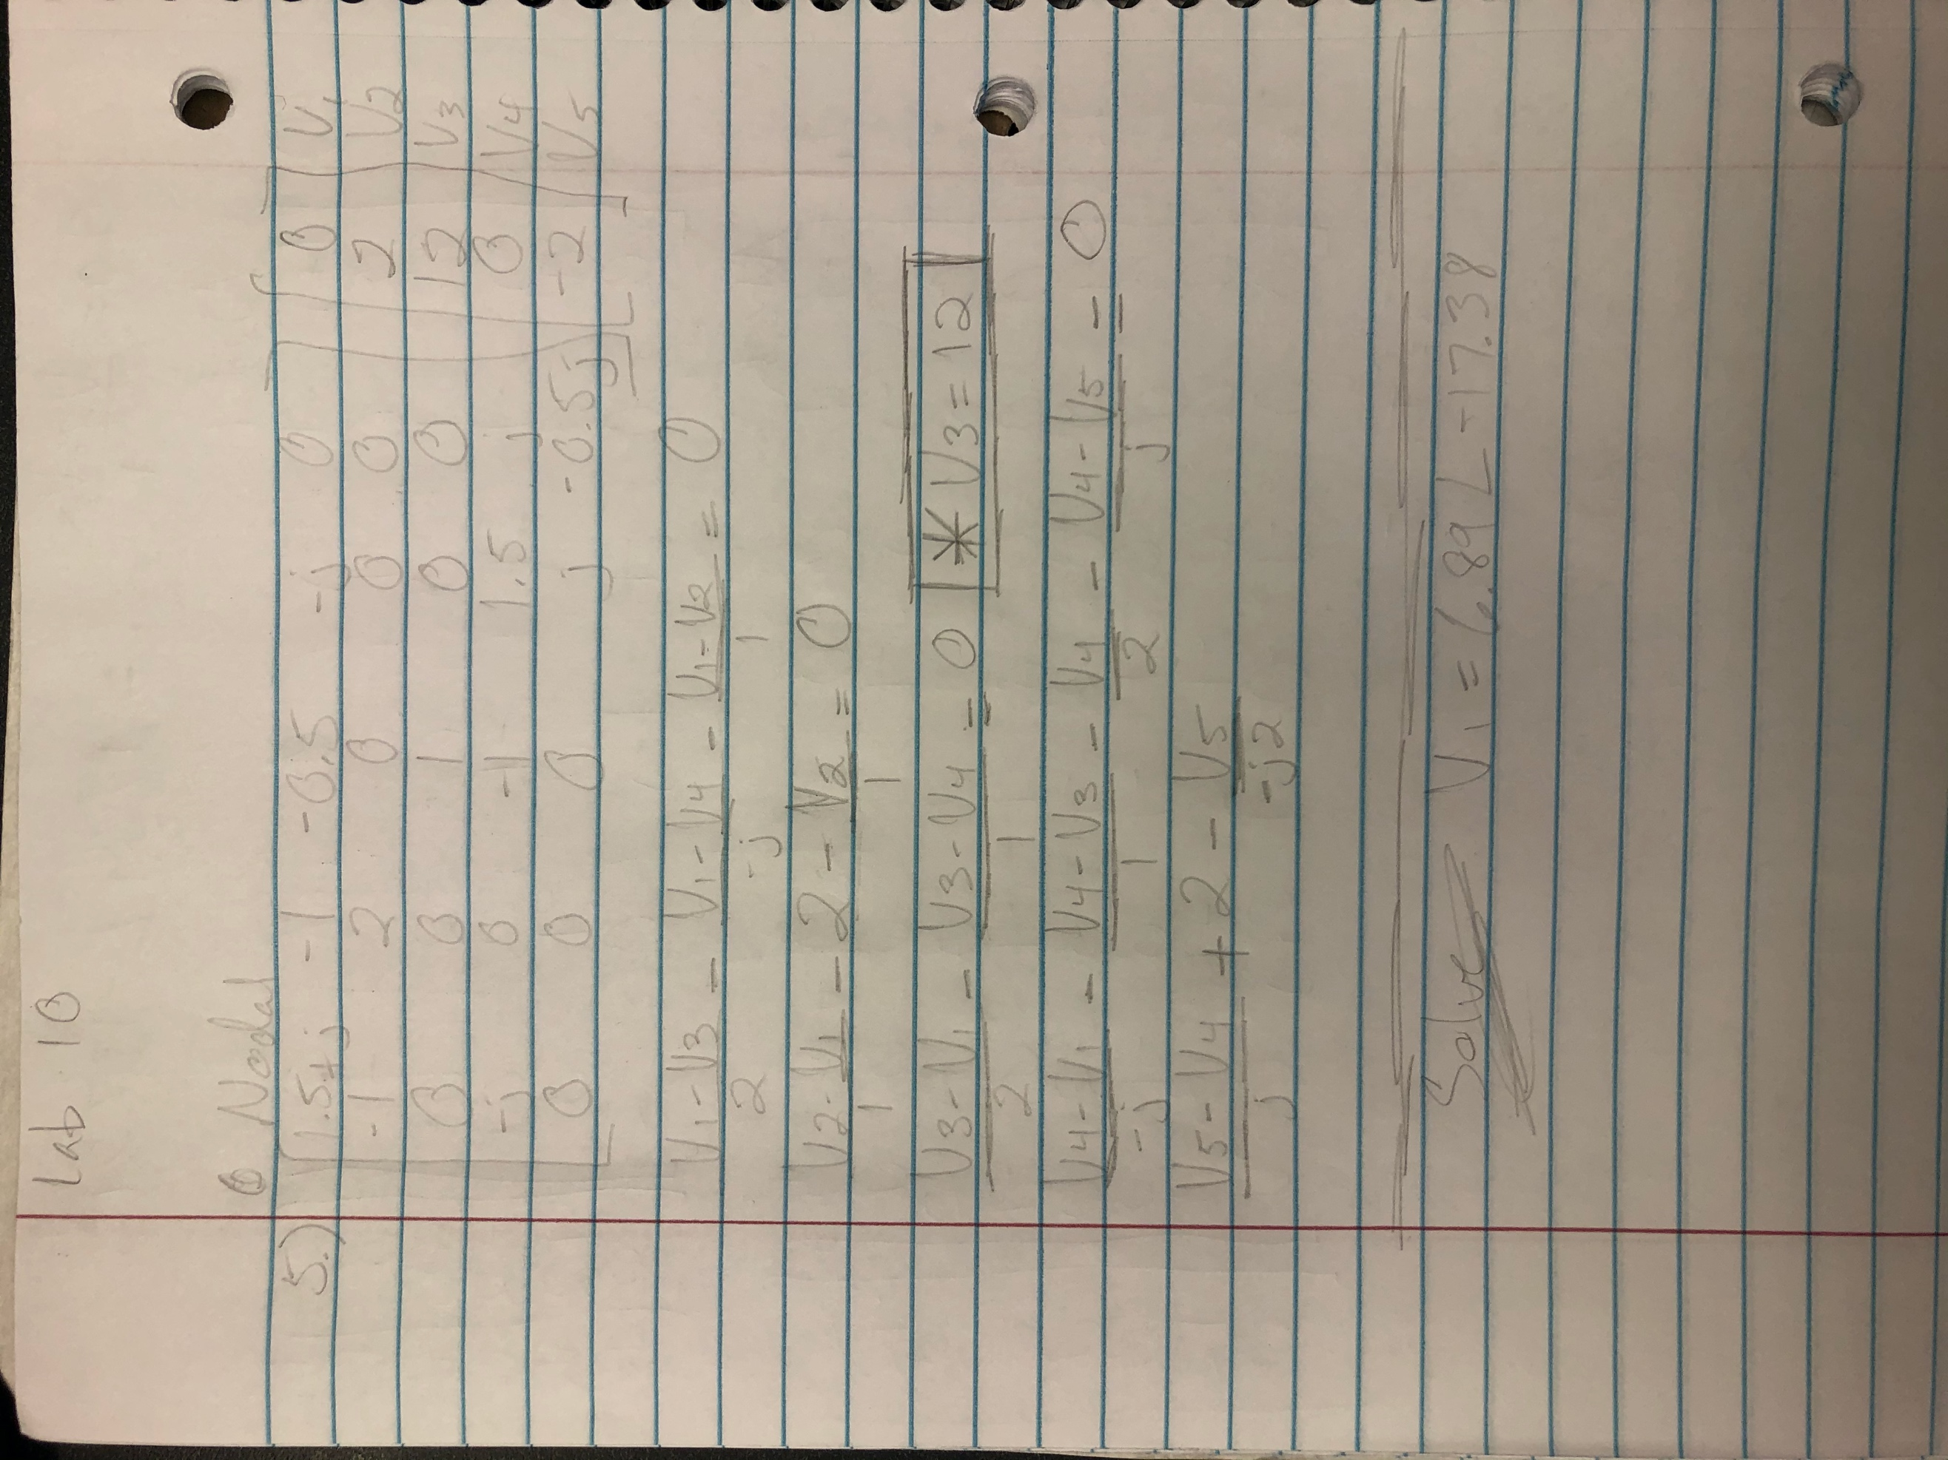

(17)

Equations for exercise 5

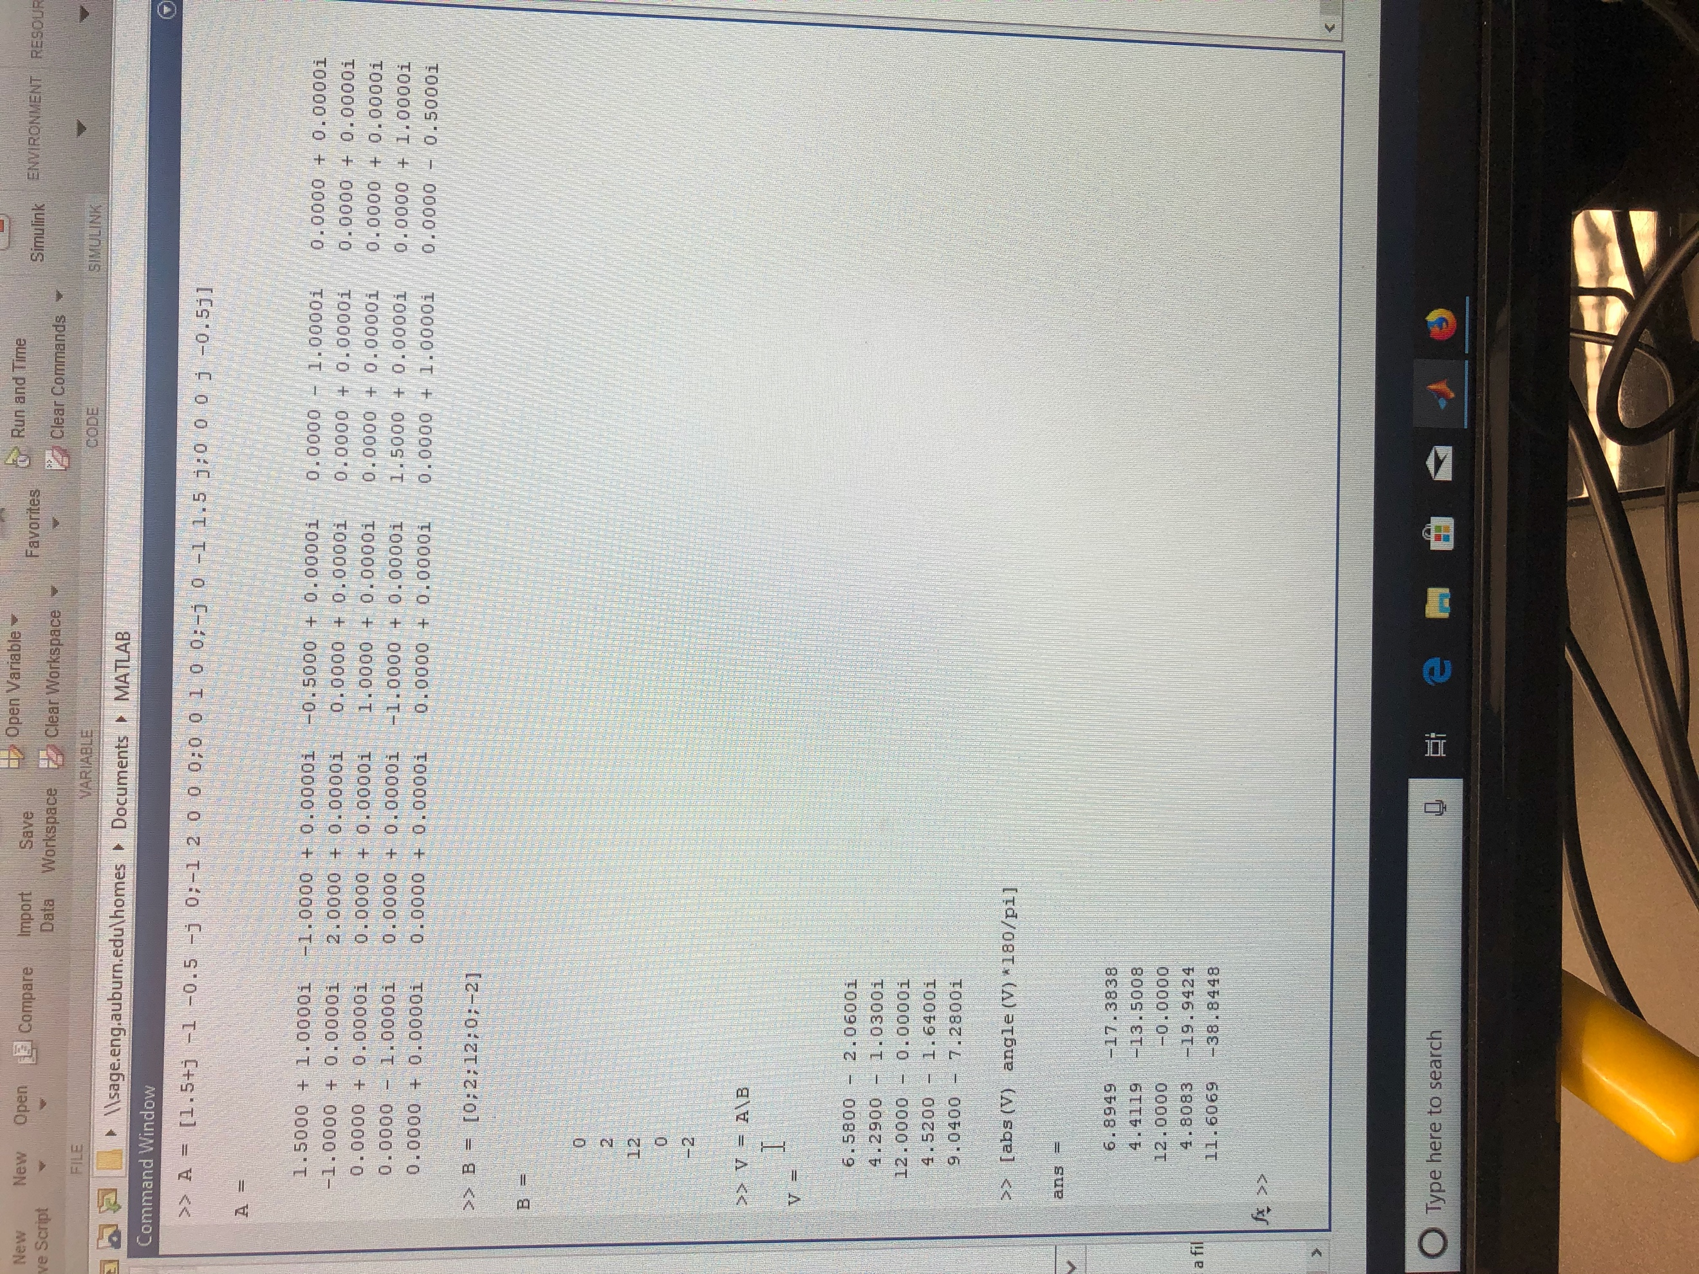

(18)

Nodal equations MATLAB

Nodal Summary Table

|  |  |  |
| --- | --- | --- |
|  | **Vector** | **Angle (degrees)** |
| **V1** | 6.8949 | -17.3838 |
| **V2** | 4.4119 | -13.5008 |
| **V3** | 12.00 | 0 |
| **V4** | 4.8083 | -19.9424 |
| **V5** | 11.6069 | -38.8448 |

Conclusion

Nodal and Mesh analysis are tools critical for an electrical engineers’ daily job. This lab is very helpful in learning to progress skills with these analysis methods, in AC circuits. AC circuit analysis is important since it is most common in the United States.

Bibliography

1. MATLAB equation to solve in exercise 1
2. MATLAB solution and solving
3. Circuit for exercise 2
4. Hand written equations exercise 2
5. Nodal equations exercise 2
6. Mesh equations exercise 2
7. Circuit for exercise 3
8. Hand written equations exercise 3
9. Nodal equations exercise 3
10. Mesh equations exercise 3
11. Circuit for exercise 4
12. Hand written equations exercise 4
13. Nodal equations exercise 4
14. Mesh equations exercise 4 part 1
15. Mesh equations exercise 4 part 2
16. Circuit for exercise 5
17. Hand written equations exercise 5
18. Nodal equations exercise 5